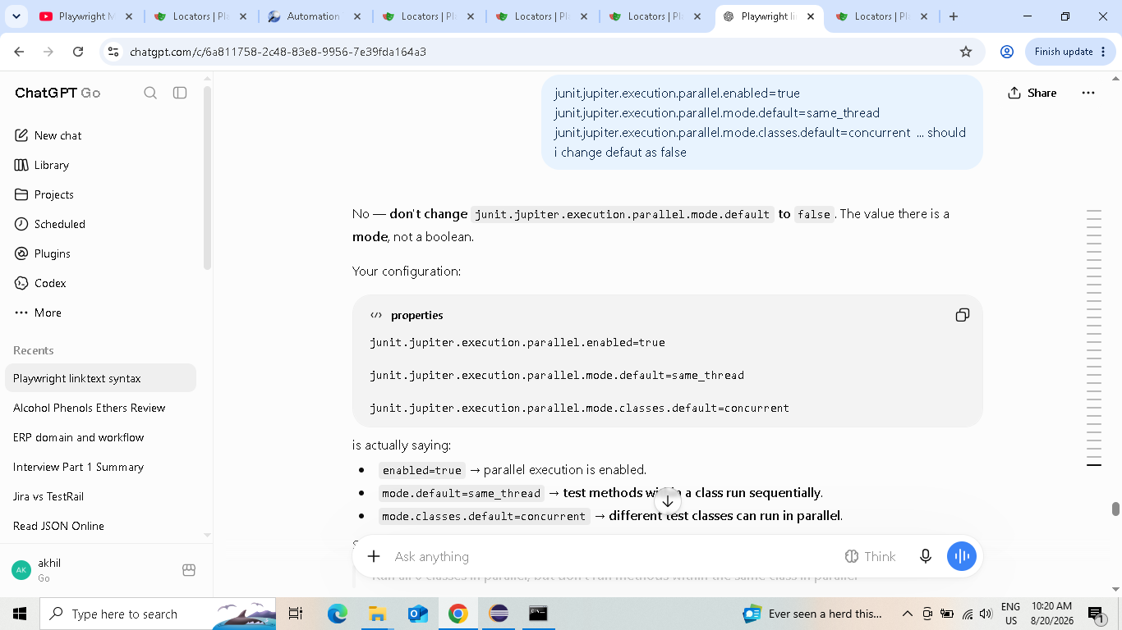
JUnit 5 + PER_CLASS + Playwright + class-level parallel execution + separate browsers/contexts/pages ✅
You can pick it up from here next time without having to rethink the architecture.
2 browsers confirmed.
That means your current architecture is working as designed:
JUnit
│
┌─────────┴─────────┐
↓ ↓
LoginTest ParallelTest
│ │
Browser #1 Browser #2
│ │
Context/Page Context/Page
│ │
CSV 1 → 2 → 3 Test
sequential sequential
So you've successfully achieved:
- ✅ Test classes execute in parallel
- ✅ Each test class gets its own Browser
- ✅ Each test invocation gets a fresh Context + Page
- ✅ Tests within a class remain sequential
- ✅ @BeforeAll runs once per class
- ✅ @AfterAll runs once per class
- ✅ No shared static Page problem

